Guide for People who have Language or Communication Disabilities
This guide describes accessibility features built into Windows and Microsoft Office, as well as different types of assistive technology products that are designed for individuals who have language or communication disabilities. Note that some sections of this guide may be useful to individuals with different types of disabilities like learning or vision.
Microsoft wants to provide the best possible experience for all our customers. If you have a disability or have questions related to accessibility, please contact the Microsoft Disability Answer Desk for technical assistance. The Disability Answer Desk support team is trained in using many popular assistive technologies and can offer assistance in English, Spanish, French, and American Sign Language. Additionally, there is a chat service which customers can use to communicate with a live agent through text. Please go to the Microsoft Disability Answer Desk site to find out the contact details for your region. If you are a government, commercial, or enterprise user, please contact the Enterprise Disability Answer Desk.
At Microsoft, our mission is to empower every person and organization on the planet to achieve more. We are committed to delivering great experiences to people with disabilities. If you have feedback to offer, or requests to make of us, we encourage you to let us know through the Microsoft Accessibility Forum.

In this Guide:
Setup Accessibility Options in Windows
Make Accessible Documents with Office
Use Accessibility Features in Office
Browse the Accessibility Features of Internet Explorer and Edge
Assistive Technology for People with Language or Communication Disabilities

Setup Accessibility Options in Windows
Ease of Access is a location where you can set up accessibility settings and programs available in Windows.
Learn more about Ease of Access

Turn on Ease of Access options
With Windows you can access commonly used accessibility options right from the sign-in screen. Press the Windows Logo Key + U to access the Ease of Access settings at the sign-in screen. On many keyboards, the Windows Logo Key is located on the bottom row of keys, to the left or right of the Alt key. There you can turn on or off Narrator, Magnifier, On-Screen Keyboard, High Contrast, Sticky Keys, or Filter Keys.

Caption 1: Ease of Access options on the Windows sign-in screen
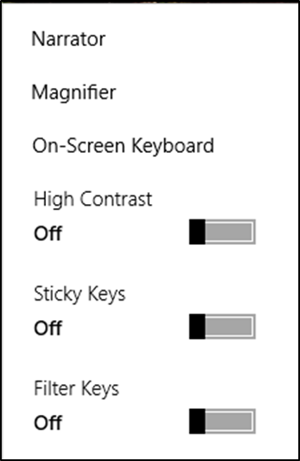
After you log on, you can also open Ease of Access by pressing the Windows Logo Key + U.
To open Ease of Access settings on a touch-enabled device, swipe in from the right edge of the screen and select All Settings > Ease of Access.

Hear text read aloud with Narrator
Narrator is the built-in screen reader that reads text on your screen aloud and describes events, such as notifications or calendar appointments. It’s also helpful for someone who is just learning English as a second language. To start or stop Narrator, press the Windows Logo Key + Enter. On Windows Mobile devices, press Windows Logo Key + Volume UP key to toggle Narrator on/off.
Learn more about Narrator
Caption 2: Ease of Access settings with Narrator section selected.
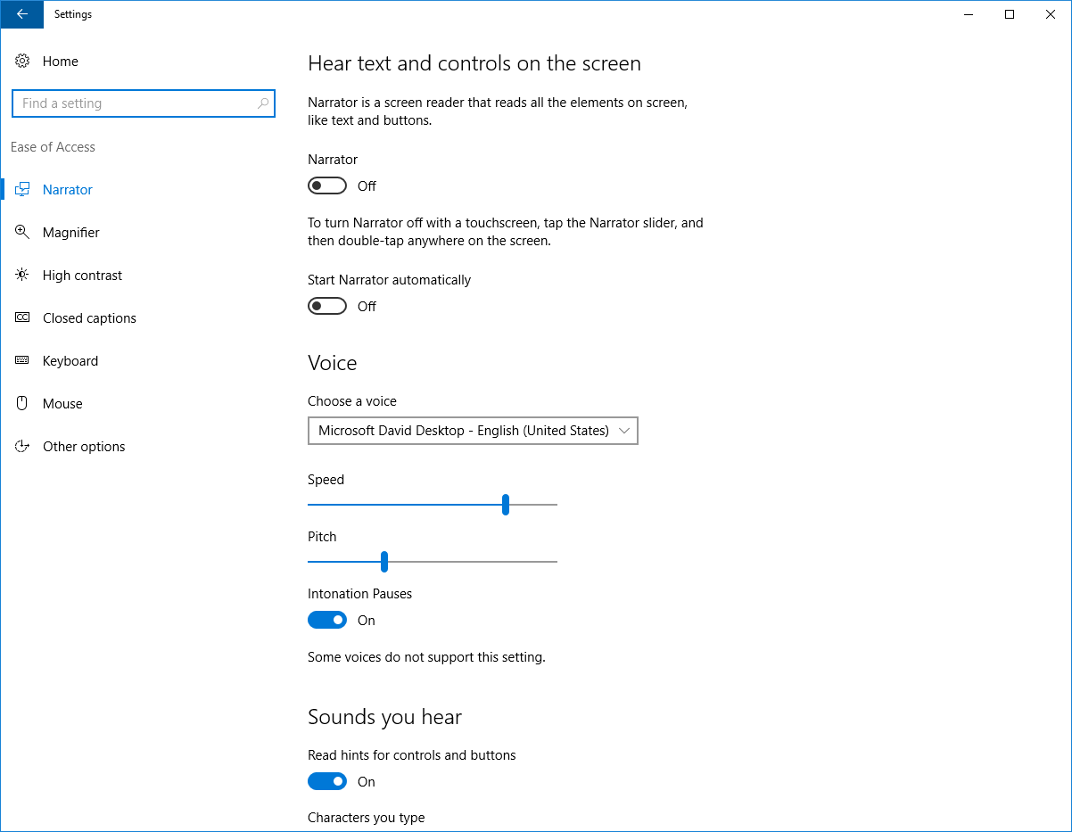

Use the On-Screen Keyboard to type
The On-Screen Keyboard is a visual keyboard that can be used by your mouse or another pointing device to select a single key or a group of keys. To open the keyboard, press the Windows Logo Key + U to open Ease of Access. Then Select Keyboard and turn on the On-Screen Keyboard. The keyboard will remain on the screen until it’s closed or minimized.

Scan through keys
The On-Screen Keyboard allows you to automatically scan through different groups of keys and select them with a single interaction. You can also customize which key starts the scanning process or use alternative input devices.
- Select the Options key.
- Select Scan through keys.
- Press the Space Bar to select the row. Then press the Space Bar again to choose the letter or symbol.
Caption 3: The On-Screen Keyboard in Windows
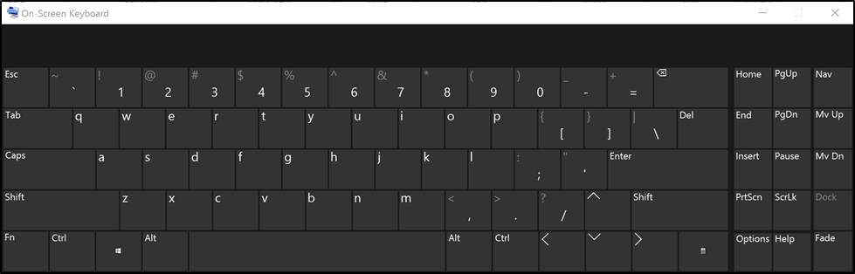
Learn more about the On-Screen Keyboard

Use the Touch keyboard
The Touch keyboard has Word Prediction, which can be useful for interacting with a touch device.

Word Prediction
As you type on the keyboard suggested words will show up at the top of the keyboard. Use this tool to find the words you are looking for.
- In the notification area select Touch keyboard .

Handwriting
The Handwriting option lets you write with a stylus (such as a Surface Pen) or your finger. That option can also be a good tool for learning cursive or signatures.
- In the notification area select Touch keyboard .
- Choose the Handwriting option.
Caption 4: An example of the Handwriting feature on the Touch keyboard.
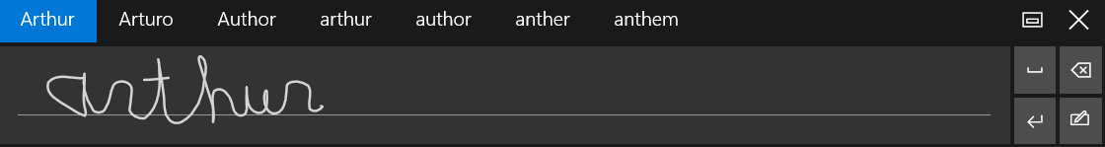
Learn more about touch keyboard

Customize sign-in settings
You can customize sign-in settings, so that accessibility features start automatically when you sign in, after you sign in, or both. To customize sign-in settings:
- Press Windows Logo Key to open Start.
- Type Ease of Access Center and select Ease of Access Center from the results.
- Select Change sign-in settings.
- Select the checkboxes for the options you would like to use and then select OK.
Caption 5: A list of sign-in settings you can change in the Ease of Access Center.
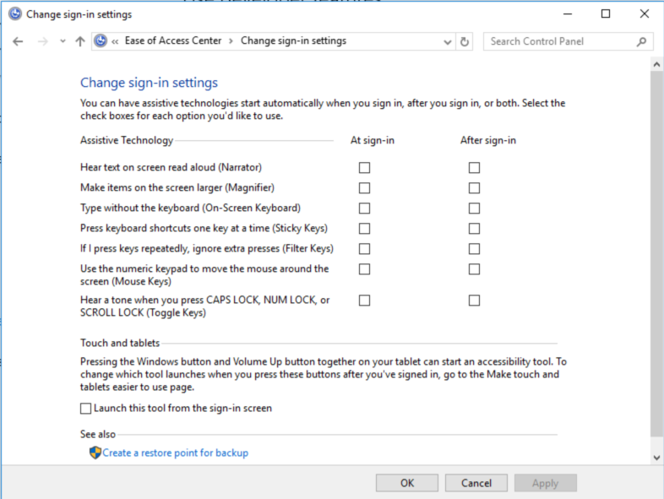

Make Accessible Documents with Office
Built-in features in Microsoft Office can help you make your documents, spreadsheets, and presentations accessible to individuals who have speech disabilities. For more information on how to make your content accessible, please visit the Office Accessibility Center and Accessibility in Office 2016 and Windows 10. Check back regularly as we frequently add new articles and product tutorials.

Accessibility Checker
Word, Excel, PowerPoint, and OneNote include an Accessibility Checker that identify some content that might be inaccessible to individuals with disabilities. You can use the Accessibility Checker while you author to inspect errors as they occur and learn how to fix issues.
To Open the Accessibility Checker:
- Open File (Alt + F).
- Select Info.
- Select Check for Issues.
- Select Check Accessibility.
Caption 6: An example of some issues found in the Accessibility Checker.
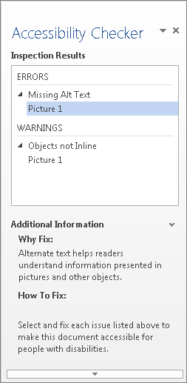
Learn more about the Accessibility Checker
Learn more about the Accessibility Checker on the Mac

Use Accessibility Features in Office
Microsoft Office comes with built-in accessibility features designed for individuals who have speech disabilities. You can also customize options in Office to meet your individual needs and preferences.

Use the Speak Command for Text-to-speech
The Speak command in Office uses text-to-speech (TTS), which is the ability of your computer to play back written text as spoken words. It may be beneficial for some users to hear the words spoken, and is also helpful to people that are learning English. Depending upon your configuration and installed TTS engines, you can hear most text that appears on your screen in Word, Outlook, PowerPoint, and other programs in Microsoft Office.
You can add the Speak command to the Quick Access Toolbar.
- Open File (Alt + F).
- Select Options.
- Select Quick Access Toolbar.
- Choose Commands Not in the Ribbon.
- Select Speak.
- Select Add.
- Select OK.
Caption 7: Word Options dialog box where the Speak command is selected to add to the Quick Access Toolbar.
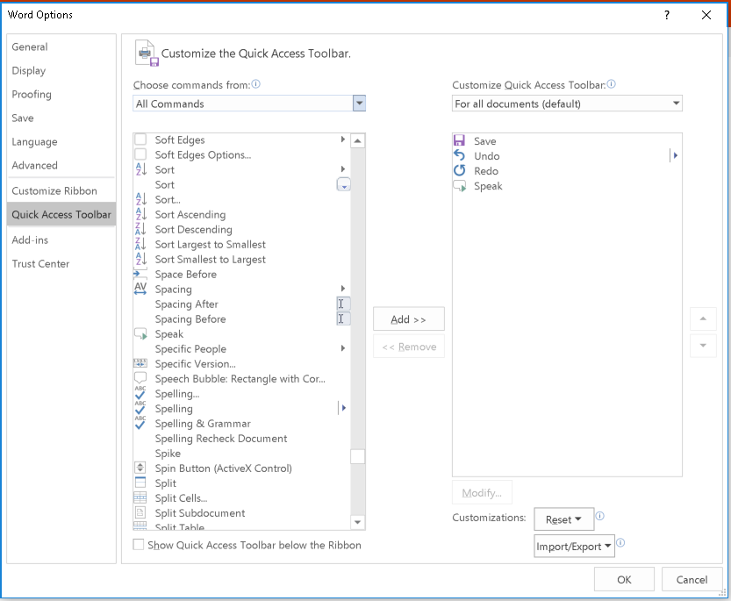
Now, you can quickly hear selected text.
- Select the text in the document you want to hear.
- Select the new Speak button in the Quick Access Toolbar.
Caption 8: Quick Access Toolbar with the Speak button activated.
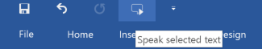
Learn more about text-to-speech

Do Things Quickly with Tell Me in Office 2016
You might have noticed a new text box on the Ribbon in Office 2016. This is Tell Me, where you can enter words or phrases about what you want to do next and quickly get to features in Office 2016.
- Press Alt + Q.
- Start typing something like “insert table” or “Accessibility Checker.”
- Select what you want to do from the list of suggestions.
Learn more about Tell Me

Office Learning Tools
Learning Tools are available in a growing number of Office applications. Here are some examples of how Learning Tools can help you with speech and language in your documents:
- Read Aloud reads text out loud with simultaneous highlighting which improves decoding, fluency, and comprehension while sustaining focus and attention.
- Text Spacing optimizes font spacing in a narrow column view to improve reading fluency.
- Syllable shows the breaks between syllables to improve word recognition and decoding.

Learning Tools for One Note
The Learning Tools for OneNote is an add-in that will add a new tab to your Ribbon in the OneNote desktop application, which includes the Immersive Reader and Dictate.
The Immersive Reader tool recognizes text from images, and highlights words as they are read aloud. Additionally, there are options to control grammar and syntax highlighting such as Syl-la-bles, which enables words to be placed into syllables and displayed on the screen.
There’s also a Dictate feature in Learning Tools. This allows you to talk directly to your computer, or input your text directly into OneNote.
Learn more about learning tools in OneNote

Learning Tools in Word
Learning Tools are now included in Office 365 version of Word 2016 desktop and online applications.
To use Learning Tools in Word 2016:
- Open any Microsoft Word document.
- On the View tab, in the Views group, select Read Mode
- From the View menu, adjust any one or all of the following:
- Page Settings (Page Color, Column Width, Layout)
- Text Settings (Syllables, Text Spacing)
- Read Aloud
Learn more about Learning Tools in Word
Learn more about Learning Tools in Word Online

Get Keyboard Shortcuts and Steps for Using Assistive Technology with Office
Office for Windows, Online, Mac, iOS, Android, and Windows Mobile provides support for assistive technologies like screen readers. You can read about the accessibility features for your specific environment at the Office Accessibility Center. There you can get all the latest accessibility information on products such as Word, PowerPoint, Excel, Outlook, and even others outside of the Office Suite such as Skype or OneDrive.
- Visit the Office Accessibility Center.
- Select the app you want to learn about.
- Navigate to the section for your device.

Speech solutions with Skype
Individuals may be able to use Skype to communicate via text rather than spoken dialogue in real time. Skype provides a single interface that unites voice communications, instant messaging, and audio, video, and web conferencing.
To send an instant message in Skype:
- Select the Contacts tab.
- Choose a person you want to IM.
- Type your message in the conversation window at the bottom of the screen.
- Press Enter on the keyboard or select the Send icon
Caption 9: An example of Instant messaging in Skype with Send circled
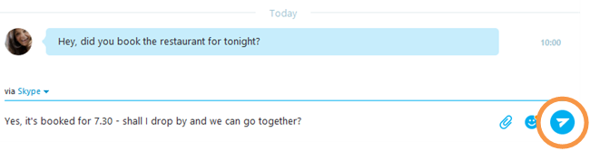
Learn more about how to send instant messaging in Skype

Find assistive technology for People with Language or Communication disabilities
People who have language or communication difficulties and impairments may be interested in the following assistive technology:
- Augmentative and assistive communication (AAC) devices are used by individuals with speech disabilities. The user types in a word, phrase, or sentence to communicate—or selects a series of symbols or pictures on the device—and the device "speaks" aloud for the user. Often these devices are used to replace a PC keyboard. In these cases, the user can use one device for both communicating and computer input.
- Touch screens are devices placed on the computer monitor (or built into it) that allow direct selection or activation of the computer by touching the screen. The ability to touch the computer screen to select is advantageous for people with language disabilities because it is a fast, direct, and intuitive alternative to using a mouse or keyboard.
- Speech synthesizers (also known as text-to-speech (TTS) systems) speak information aloud in a computerized voice.
Learn more about Assistive Technology products for Windows
Guide last updated on 2/7/2017.

